**Chapter 2 Exercises**

2.1 Define Tags for attached IO 2

2.1.1 Create a new Tag Table and Add Tags 3

1) Create a new Tag Table and Add Tags. 3

2.1.2 Create a Simple latch in the Main routine 4

**2.1 Configure Tags and Test Attached IO**

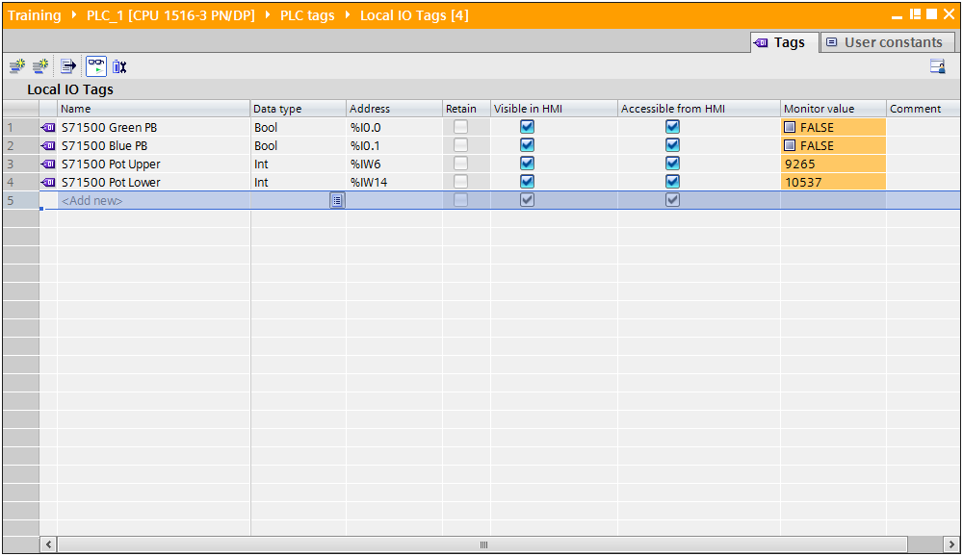

* 1. Define Tags for attached IO

**Description**

Tags are symbolic names used to access addresses in the PLC program. The TIA Portal, along with the PLCs, supports tag-based addressing. Associating a name with an address is accomplished via the Tag table.

**Objectives**

Upon completion of this exercise, the student shall be able to:

* Define tags for attached IO.
* Download and test the program using the monitor function.

**Prerequisites**

The following prerequisites must be completed before this exercise is started:

* Chapter 1 exercises have been completed.

### 2.1.1 Create a new Tag Table and Add Tags

|  |
| --- |
| 1. Create a new Tag Table and Add Tags. 2. From the Project tree, expand the branch under the S7-1500 PLC_1 labeled “PLC tags”. 3. Double click on “Add new tag table”. A tag table with a default name is added.      1. Rename the tag table to “Local IO Tags”, then double-click on the new table to open it for editing.      1. Define the tags as shown the figure below. Pay particular attention to data types and addresses.      1. From the button bar at the top of the Tag table editor, click the “Monitor” button to connect to the PLC and monitor the tag values.      1. Exercise the attached devices and monitor the values. 2. When finished, deactivate Monitor mode. 3. Save your project. |

### Create a Simple latch in the Main routine

|  |
| --- |
| 1. From the Project tree, expand the branch under PLC_1 labeled “Program blocks” 2. Double click on the entry “Main [OB1]” to open the main cyclic program for edting. 3. Create the logic shown below.      1. Once the logic is created. Select the tag table “Local IO” from the Project tree by clicking once, which will populate the Details view in the lower left. If the Details view isn’t fully visible, expand it.. 2. Drag and drop tags from the details view to the contacts.      1. While in the program editor, enter a new tag “Latch_Output” for the coil element and for the latching contact. See the figure below.      1. Right mouse click on “Latch_Output”. From the menu that appears, select “Define tag”      1. Enter the address details for the tag. Assign it to the “Global Outputs” and the “Default tag table”. Set the address to %Q50.0, then click Define to create the tag.      1. Your completed rung of logic should look like the figure below:      1. Save your project. 2. “Download” the changes to the CPU. 3. Monitor the logic and latch and unlatch the circuit using the green and blue push buttons.     *This concludes Chapter 2 exercises*. |